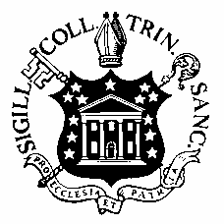

To be completed by student (please type):

Health Professions Advisory Committee

Trinity College
300 Summit Street
Hartford, CT 06106

COMMITTEE LETTER AND ALL ASSOCIATED INDIVIDUAL LETTERS OF RECOMMENDATION

NAME CLASS YEAR

Allopathic Medical School

PROFESSIONAL SCHOOL or PROGRAM AAMC ID

Sign one of the boxes below:

I wish all of these letters to be CONFIDENTIAL and hereby waive my right of access to them.

I wish these letters to be NON-CONFIDENTIAL
and hereby retain my right of access to them.

SIGNATURE DATE SIGNATURE DATE

This letter has been prepared by the Health Professions Advisory Committee (HPAC) for use by admissions officials of health profession schools. It is based upon some or all of the following documents: student’s written personal statement and activities list, transcript, evaluation by the Committee, faculty recommendations and any other recommendation letters submitted on behalf of this student.

Trinity College Health Professions Advisory Committee

Alison J. Draper, Ph.D. Date
Director, Center for Interdisciplinary Science
Chair, Health Professions Advising Committee

